

Experiment No.: 02

Title: Git and GitHub
Batch: B–1 Roll No.: 16010422234 Experiment No.: 02
_____________________________________________________________________________

Aim: Study Git, GitHub and upload an application on GitHub.
_____________________________________________________________________________

Resources needed: GitHub Account, Git installation
_____________________________________________________________________________

Theory:
Introduction to Git
Git is a version control system for tracking changes in computer files and coordinating work on those files among multiple people. It is primarily used for source code management in software development, but it can be used to keep track of changes in any set of files.

Git Commands
Git Init

The git init command creates a new Git repository. It can be used to convert an existing, unversioned project to a Git repository or initialize a new, empty repository.

Git Add
When we create, modify or delete a file, these changes will happen in our local and won't be included in the next commit (unless we change the configurations). We need to use the git add command to include the changes of a file(s) into our next commit. The git add command doesn't change the repository and the changes are not saved until we use git commit. The git add command adds new or changed files in your working directory.
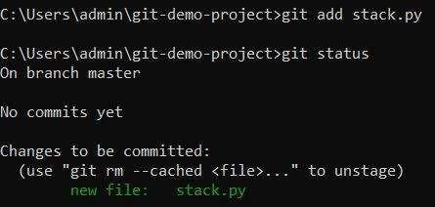
Git Commit
A commit, or "revision", is an individual change to a file (or set of files). It's like when you save a file, except with Git, every time you save it creates a unique ID (a.k.a. the "SHA" or "hash") that allows you to keep record of what changes were made when and by who. In version control systems, a commit is an operation which sends the latest changes to the source code to the repository, making these changes part of the head revision of the repository.
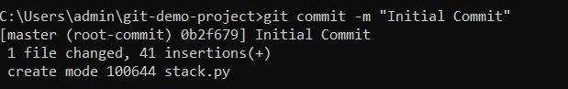

Git-Push and Pull
Push operation: The git push command is used to upload local repository content to a remote repository. Pushing is how you transfer commits from your local repository to a remote repository. The command for push is git push remote –all.
Pull operation: The git pull command is used to fetch and download content from a remote repository and immediately update the local repository to match that content. The command is: git pull <remote>.

Git Clone
Git clone is a Git command line utility which is used to target an existing repository and create a clone, or copy of the target repository. In this page we'll discuss extended configuration options and common use cases of git clone. Clones a repository into a newly created directory, creates remote-tracking branches for each branch in the cloned repository (visible using git branch --remotes), and creates and checks out an initial branch that is forked from the cloned repository’s currently active branch.

Branches: Git branches are effectively a pointer to a snapshot of your changes. When you want to add a new feature or fix a bug, no matter how big or how small, you spawn a new branch to encapsulate your changes. This makes it harder for unstable code to get merged into the main code base, and it gives you the chance to clean up your future's history before merging it into the main branch.
_____________________________________________________________________________

Procedure:
- Download Git tool from official Git website: https://git-scm.com/downloads
- Create GitHub Account https://github.com/join
- Link Git with GitHub with credentials
- Create a folder on GitHub
- Clone the folder
- Execute Git Commands: version, global, init, add, commit, checkout, push, pull, clone, branch, merge etc.
- Write any sample web application and expose it on localhost.
- Push application on GitHub
_____________________________________________________________________________

Results: (Document with screenshots)
- Application code
- Pushed file on GitHub dashboard

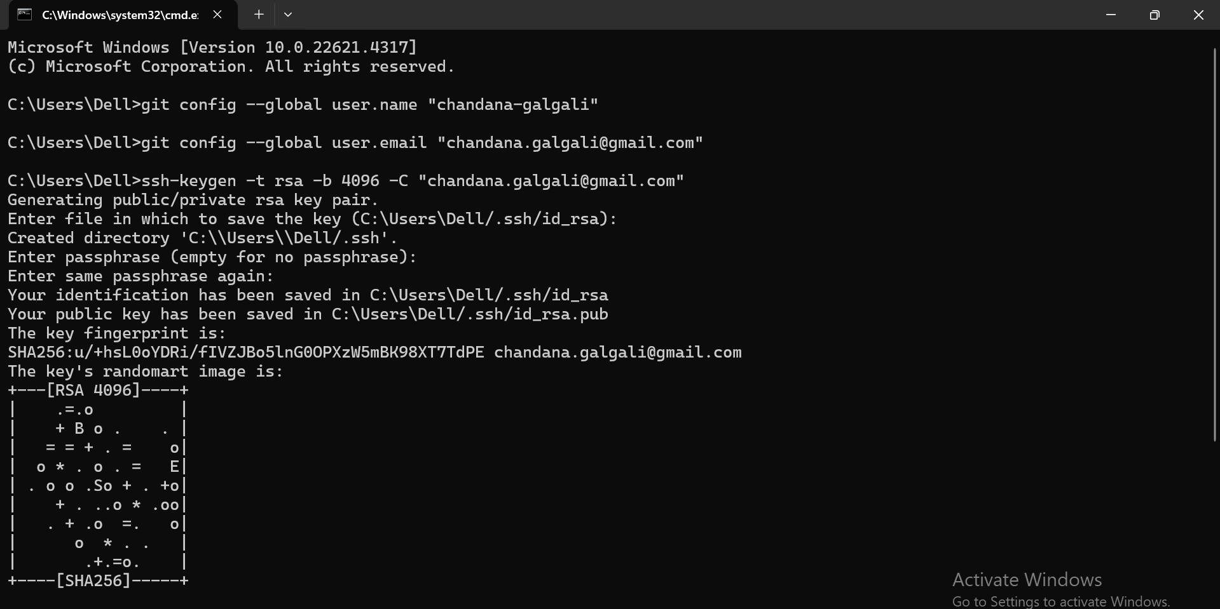

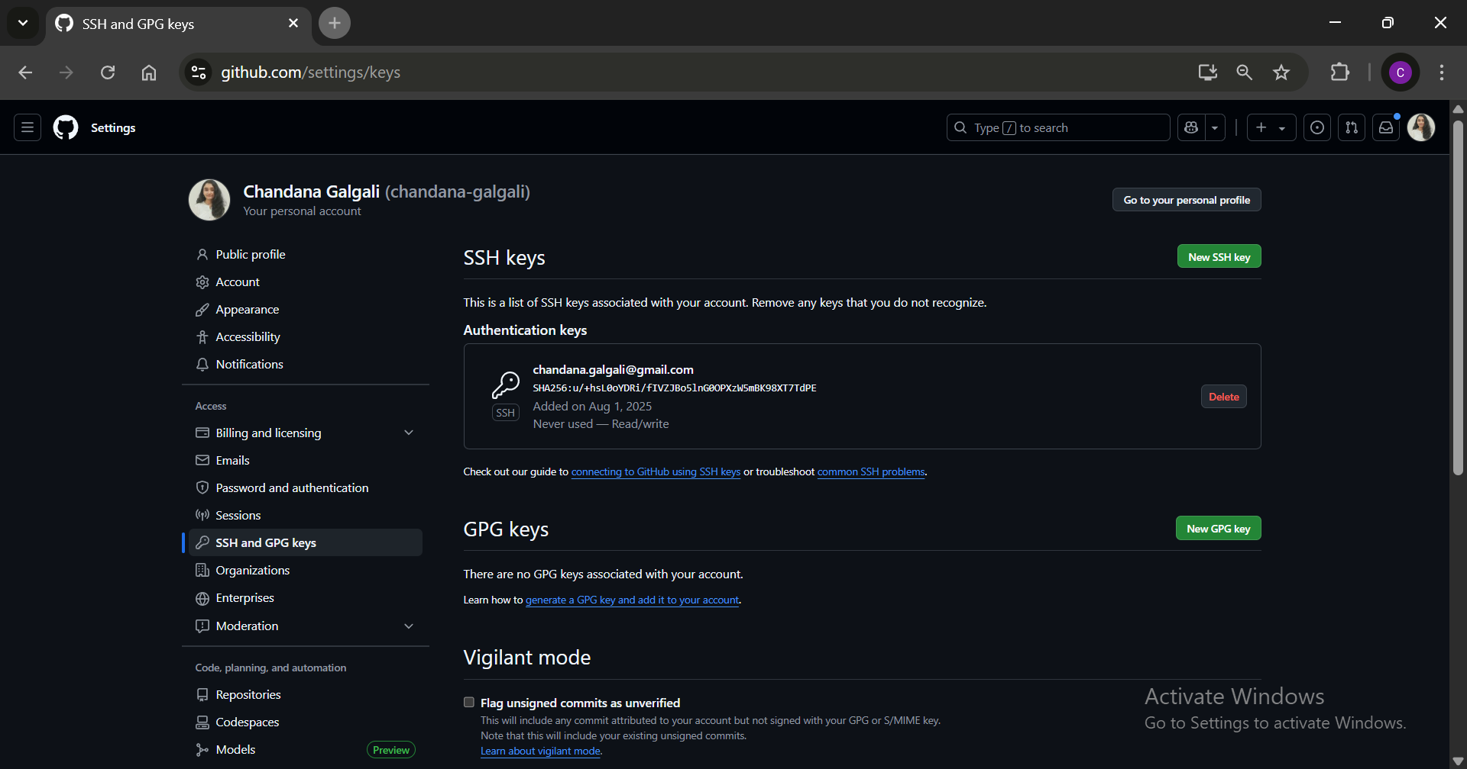

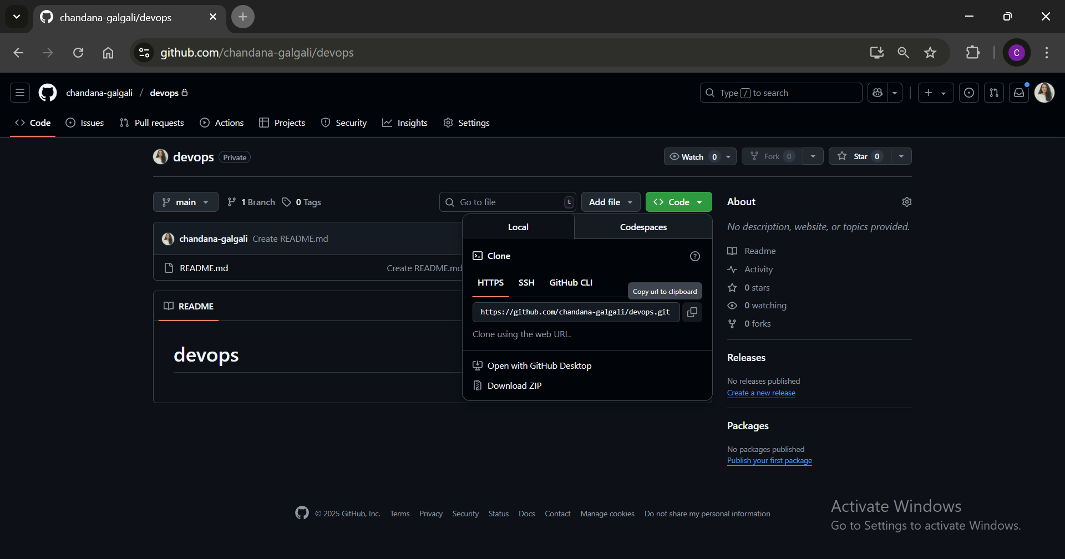

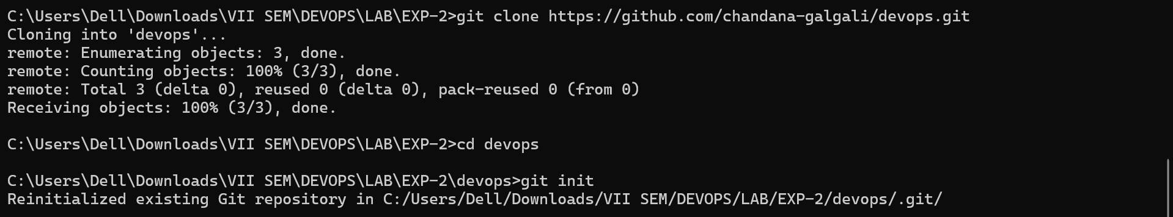

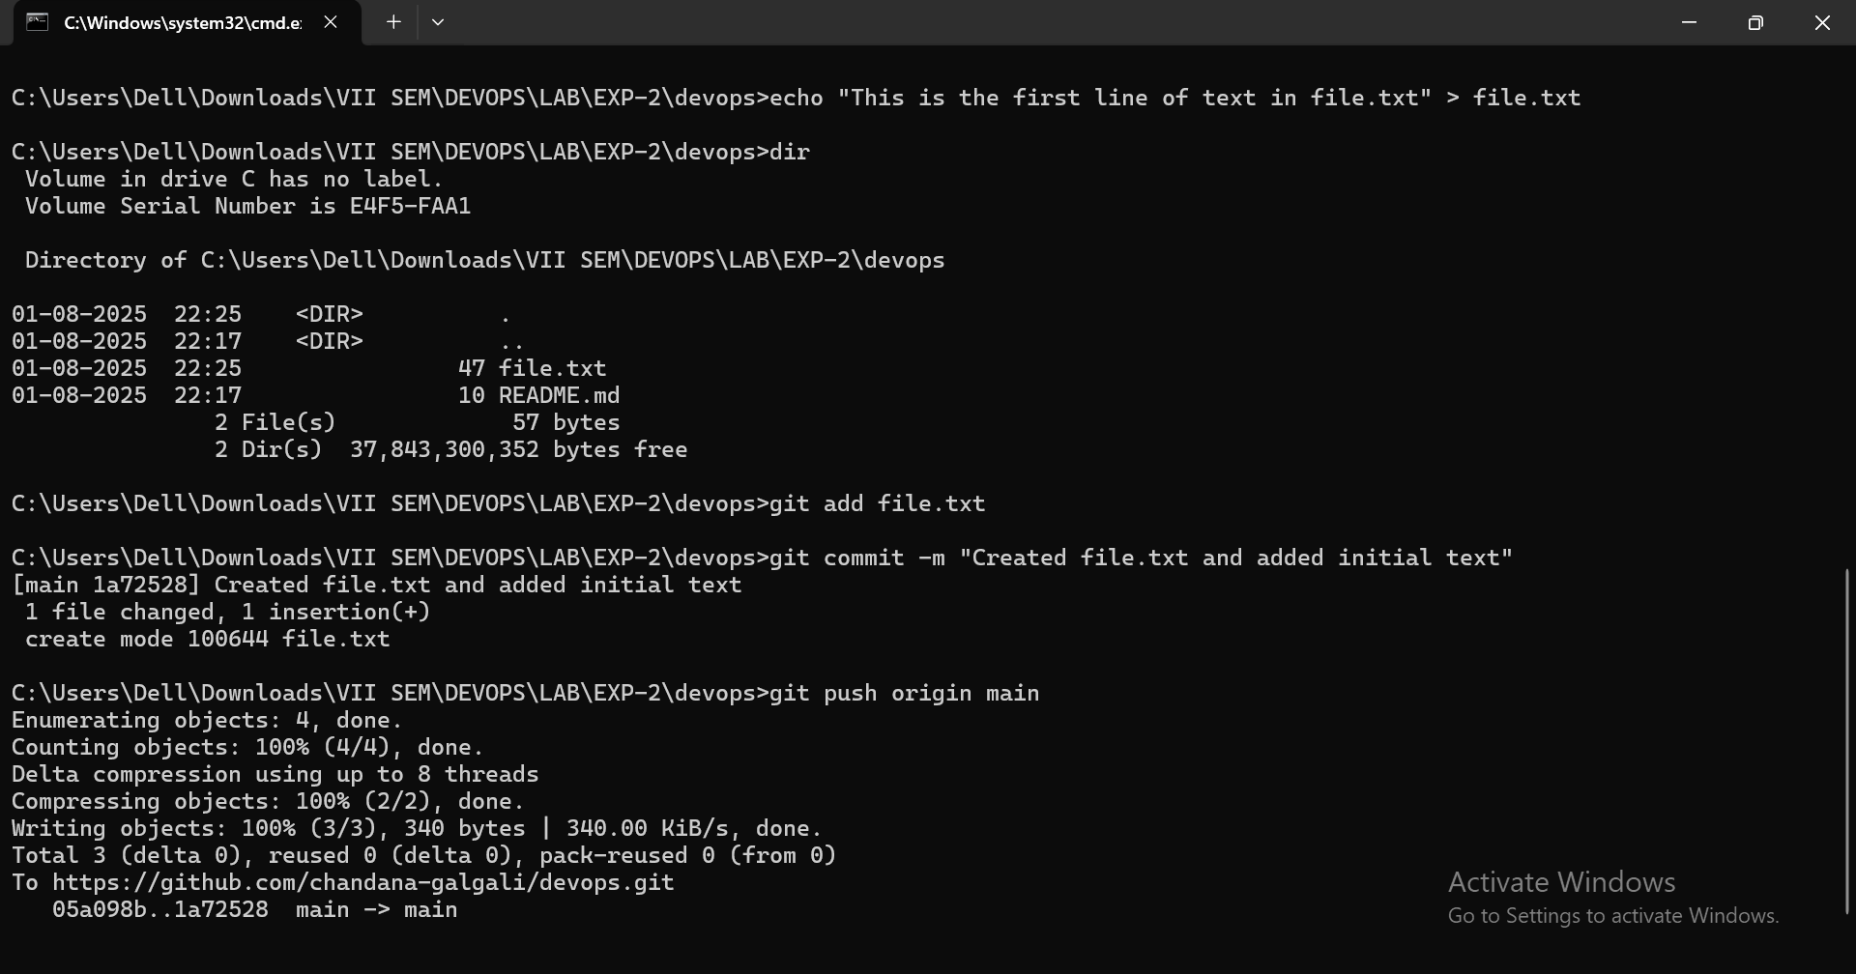

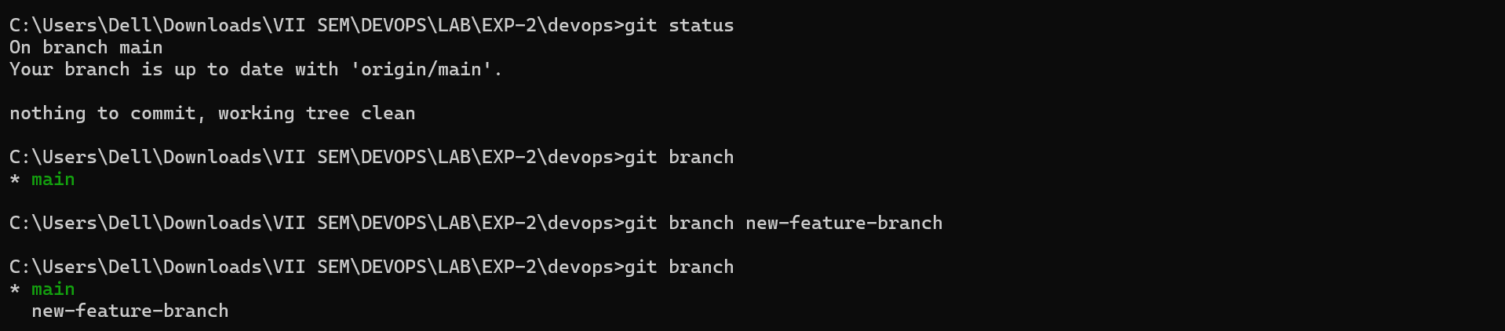

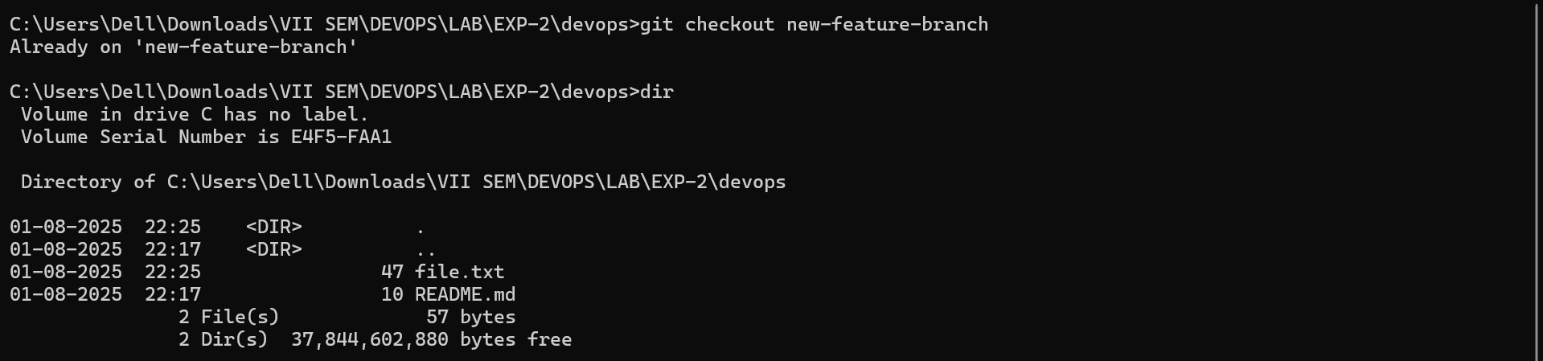

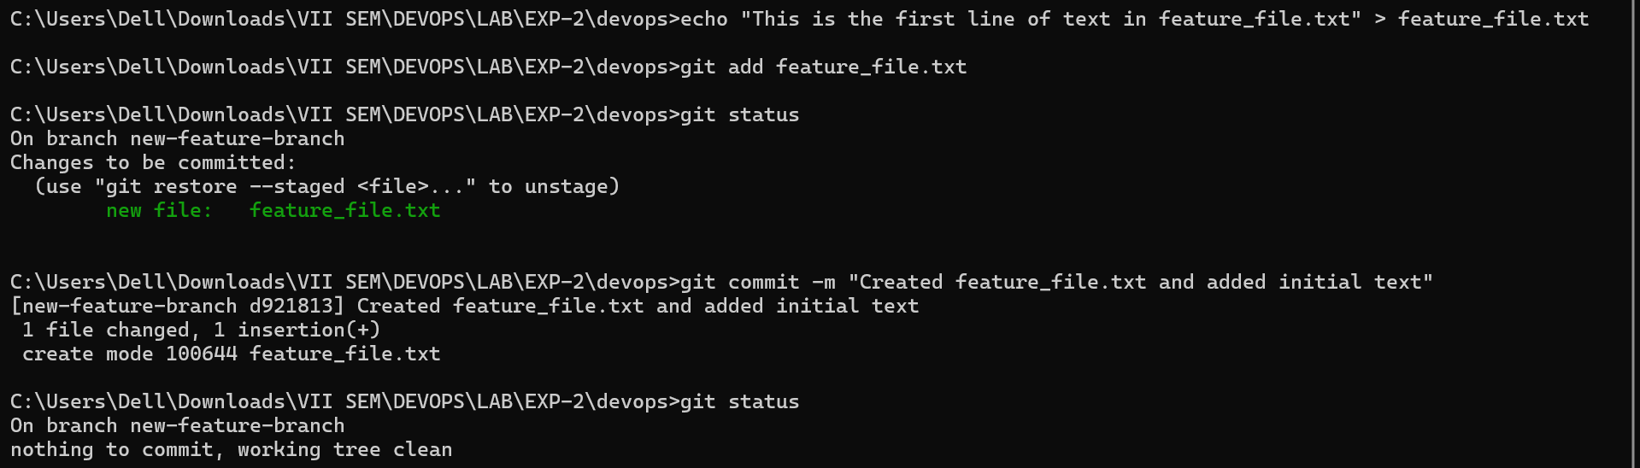

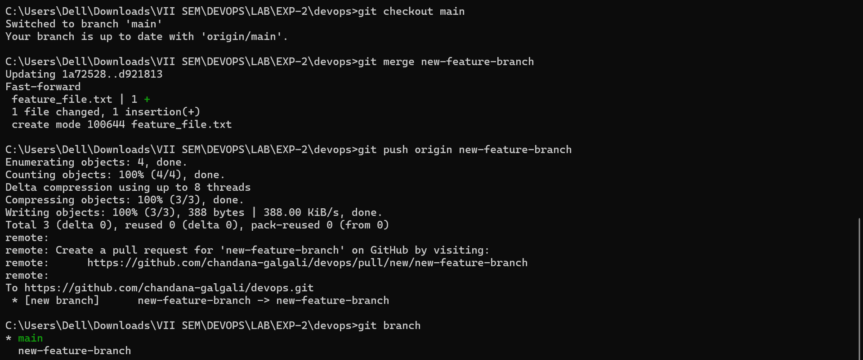

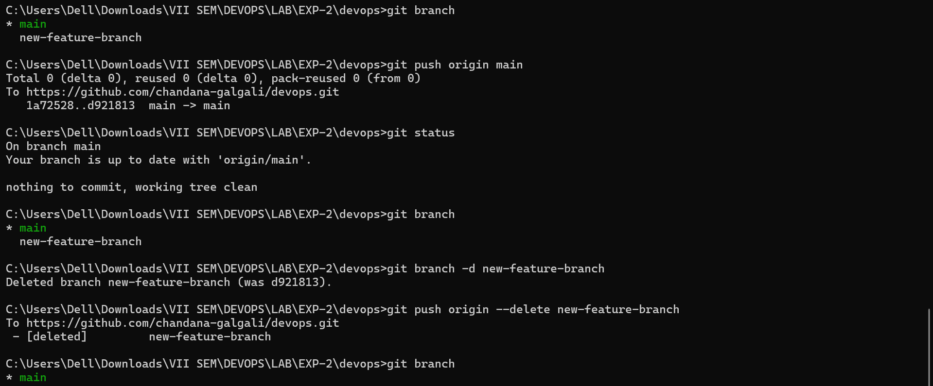

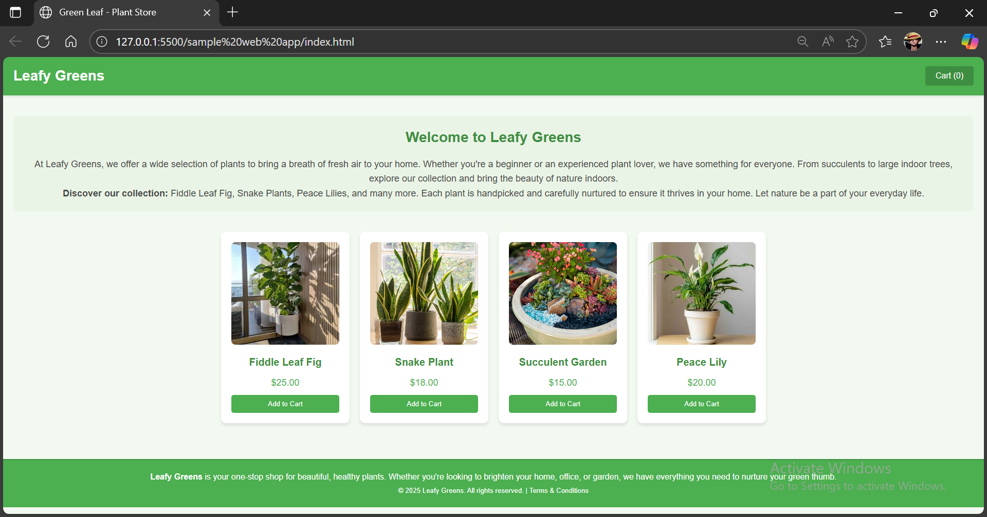

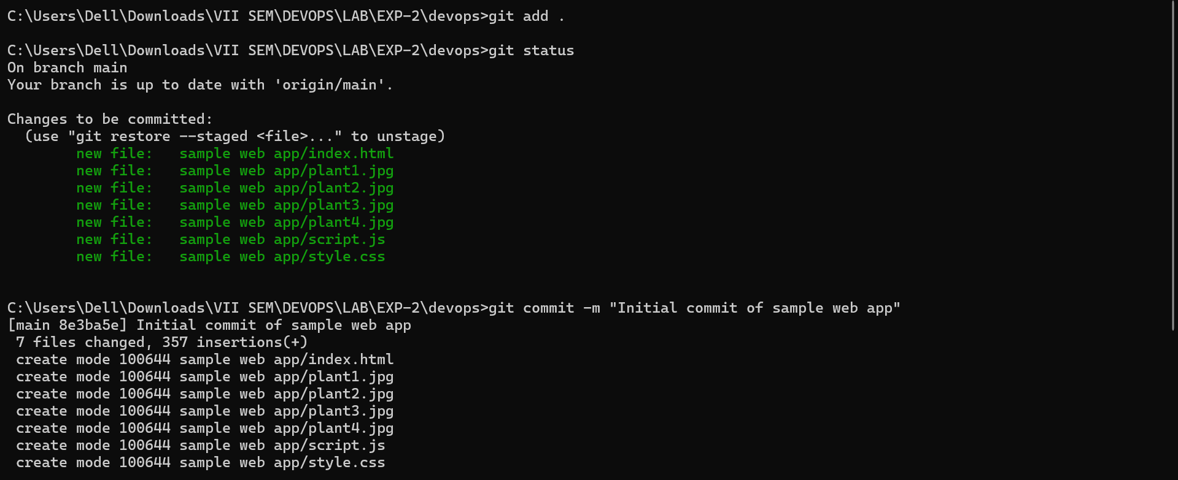

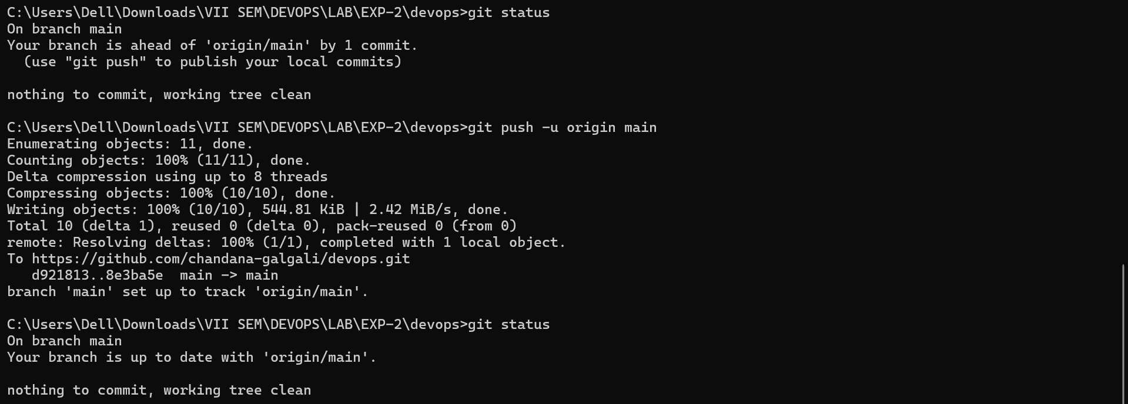

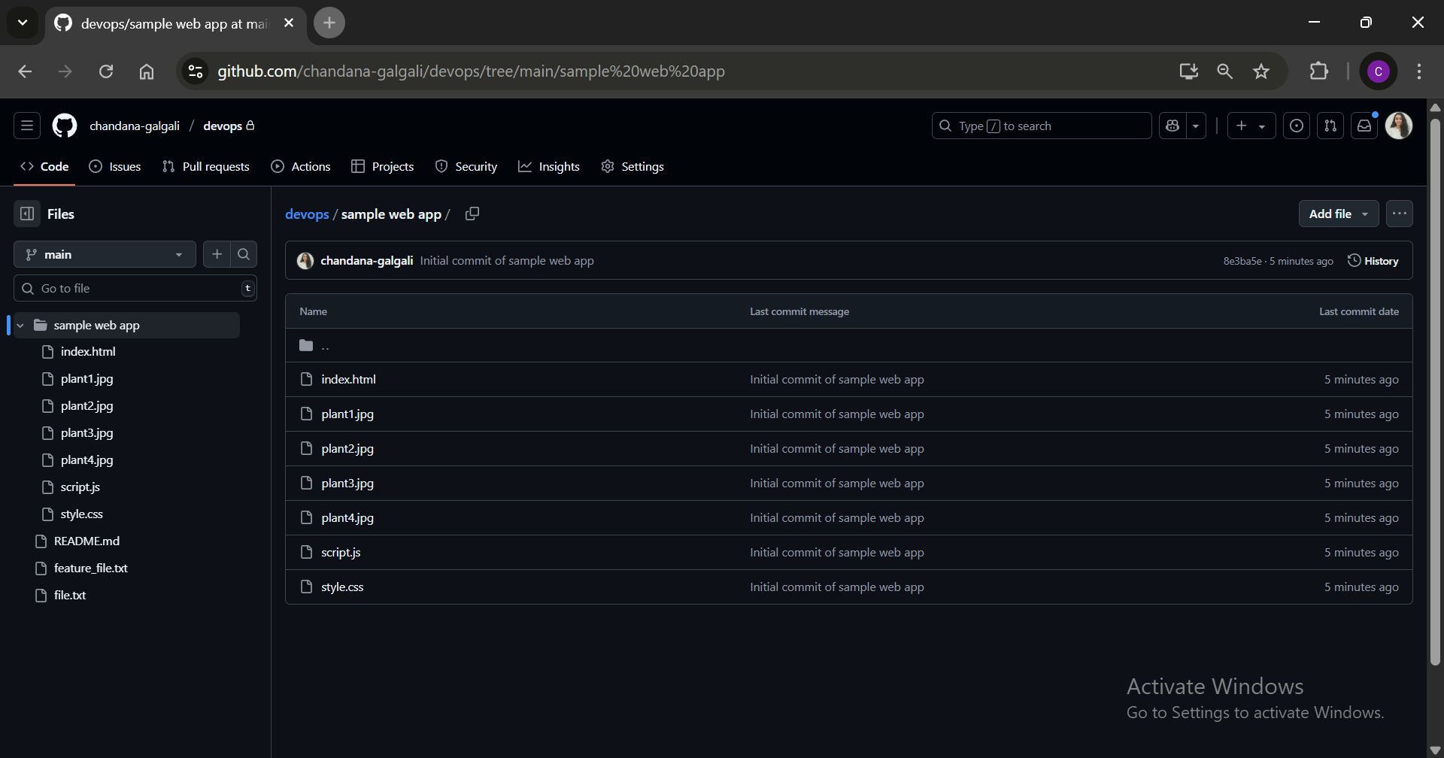

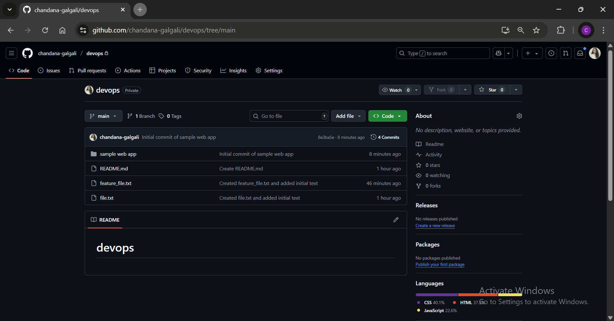
_____________________________________________________________________________
Questions:
- What is the difference between Git and GitHub?
Git is a distributed version control system used for tracking changes in source code and coordinating work among developers. It allows for local version control on a developer's machine. GitHub is a cloud-based hosting service for Git repositories. It provides a web interface for managing Git repositories, collaborative features like pull requests, issue tracking, and continuous integration services.

- What is Master and Branch in Github?
The Master branch in Git (now commonly referred to as the Main branch) is the default branch created when a new repository is initialized. It often represents the production-ready version of the code. A Branch is a pointer to a snapshot of your changes. Developers use branches to work on new features or bug fixes without affecting the main codebase. Once the work on a branch is completed, it can be merged back into the main branch.
_____________________________________________________________________________

Outcomes: CO3 – Comprehend the effective code building and testing process
_____________________________________________________________________________

Conclusion: (Conclusion to be based on the Results and outcomes achieved)
In this experiment, we learned how to use Git and GitHub for version control and collaboration in software development. Git allows tracking code changes, while GitHub provides a platform for hosting and sharing repositories. We initialized a Git repository, created branches, made changes, and pushed them to GitHub. We also cloned a repository from GitHub, demonstrating local and remote repository synchronization. This hands-on experience helped us understand version control workflows and the importance of branches for collaboration.
_____________________________________________________________________________

Grade: AA / AB / BB / BC / CC / CD / DD

Signature of faculty in-charge with date
_____________________________________________________________________________

References:
Books/ Journals/ Websites:
- https://www.w3schools.com/git/git_install.asp?remote=github
- https://opensource.com/article/18/1/step-step-guide-git
- Effective DevOps: Building a Culture of Collaboration, Affinity, and Tooling at Scale, Jennifer Davis, Ryn Daniels, O'Reilly Media June 2016.
- Practical DevOps: Implement DevOps in your organization by effectively building, deploying, testing, and monitoring code,Joakim Verona, Packt Publishing, 2nd Edition,2016
_____________________________________________________________________________

